 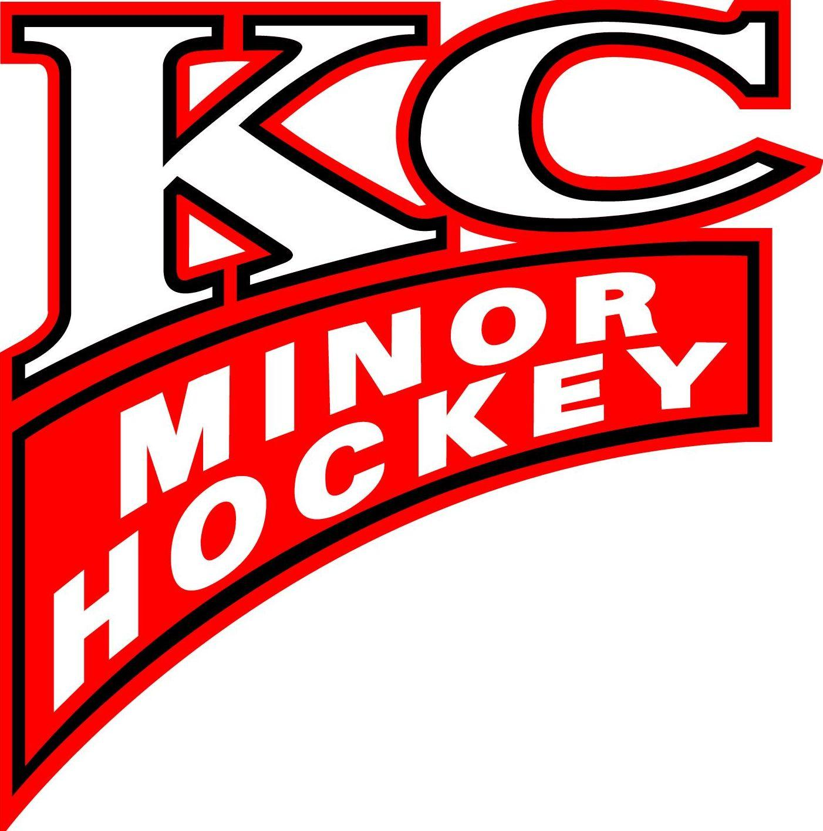

KC MINOR HOCKEY ASSOCIATION

Dear,

The KC MIDGET A Hockey Team is preparing for the upcoming hockey season in the Thunder Bay Minor Hockey Association. To assist in team expenses, our team is seeking individual player sponsorships. As a sponsor, the name of your corporation or organization will be recognized on our web page for the entire season.

Your $___________ Sponsorship will directly assist the KC KC MIDGET Hockey Team and will be used specifically for extra practice time, tournament and general operating expenses.

Thank you for considering our request. Should you have any questions please do not hesitate to contact the Team Manager RICK ONGARO at 628-7163

Sincerely,

Rick Ongaro

On behalf of the KC MINOR HOCKEY ASSOCIATION

KC KC MIDGET Hockey Team